Homework Machine Learning 3cw1

205Q001019

ທ້າວ ນູຊົ່ວ ເຮີ

ແກ້ບົດເຝິກຫັດ ຂໍ້ 2.1

1. ຈົ່ງນຳໃຊ້ຄຳສັ່ງ Python ເພື່ອສະແດງຂໍ້ມຸນຈາກຊຸດຂໍ້ມູນ Data.csvໃສ່ໃນຕາຕະລາງໃຫ້ສົມບູນ

|  |  |  |  |  |
| --- | --- | --- | --- | --- |
|  | Country | Age | Salary | Purchased |
| 0 | France | 44.0 | 72000.0 | No |
| 1 | Spain | 27.0 | 48000.0 | Yes |
| 2 | Germany | 30.0 | 54000.0 | No |
| 3 | Spain | 38.0 | 61000.0 | No |
| 4 | Germany | 40.0 | Nan | Yes |
| 5 | France | 35.0 | 58000.0 | Yes |
| 6 | Spain | Nan | 52000.0 | No |
| 7 | France | 48.0 | 79000.0 | Yes |
| 8 | Germany | 50.0 | 83000.0 | No |
| 9 | France | 37.0 | 67000.0 | Yes |

2. ຈົ່ງນຳໃຊ້ຄຳສັ່ງ info() ເພື່ອສະແດງຂໍ້ມຸນໃນຕາຕະລາງໃຫ້ສົມບູນ

ຄຳສັ່ງ:

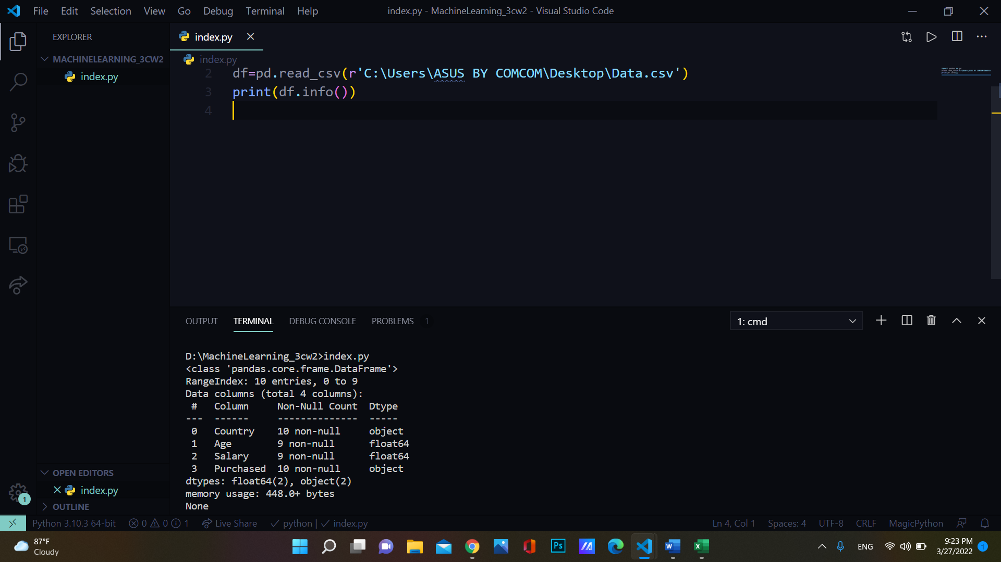

|  |  |  |  |
| --- | --- | --- | --- |
|  | Column (Features) | Not-Null Count | Dtype |
| 0 | Country | 10 non-null | object |
| 1 | Age | 9 not-null | float64 |
| 2 | Salary | 9 not-null | float64 |
| 3 | Purchased | 10 non-null | object |

3. ຈົ່ງກວດສອບຂໍ້ມູນສູນຫາຍ (Missing Values) ດ້ວຍຄຳສັ່ງ isna(), isnull().values.any(),

isnull(),isnull().sum(), isnull().sum().sum() ຫຼື , ດ້ວຍການລາຍງານເປັນຕາຕະລາງ

#ຄຳສັ່ງ isna()

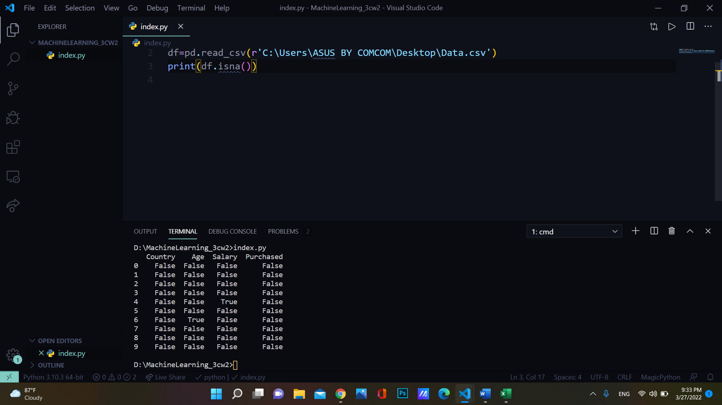

|  |  |  |  |  |
| --- | --- | --- | --- | --- |
|  | Country | Age | Salary | Purchased |
| 0 | false | false | False | false |
| 1 | False | False | False | False |
| 2 | False | False | False | False |
| 3 | False | False | False | False |
| 4 | False | False | True | False |
| 5 | False | False | False | false |
| 6 | False | True | False | False |
| 7 | False | False | False | False |
| 8 | False | False | False | False |
| 9 | false | False | false | False |

#ຄຳສັ່ງ isnull().values.any()

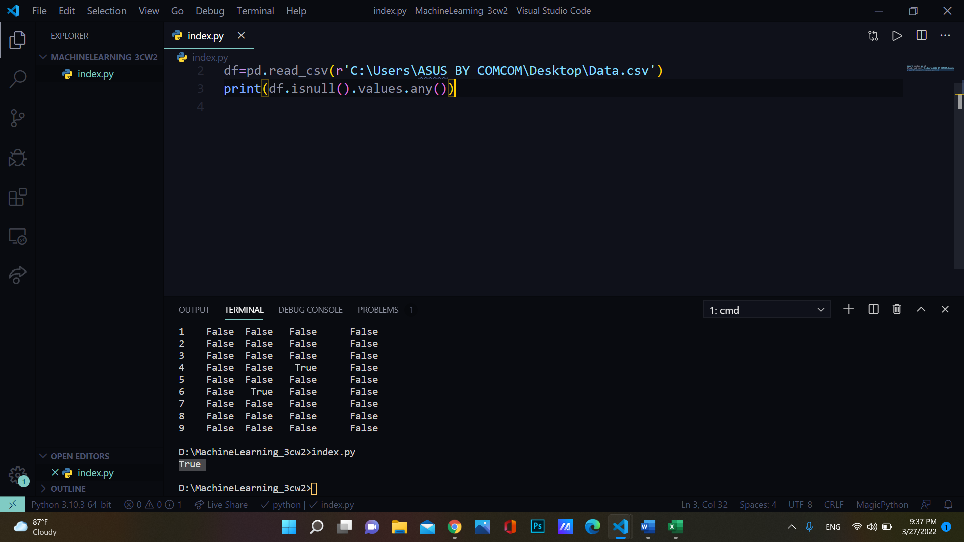

ຜົນອອກ: True

#ຄຳສັ່ງ isnull()

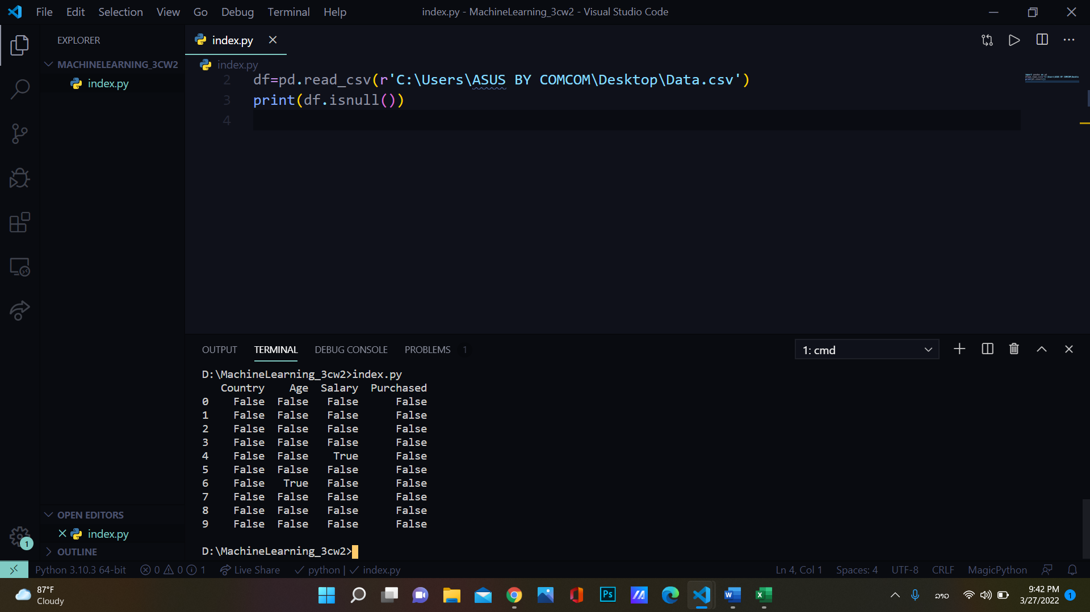

ຜົນອອກ :



#ຄຳສັ່ງ isnull().sum()

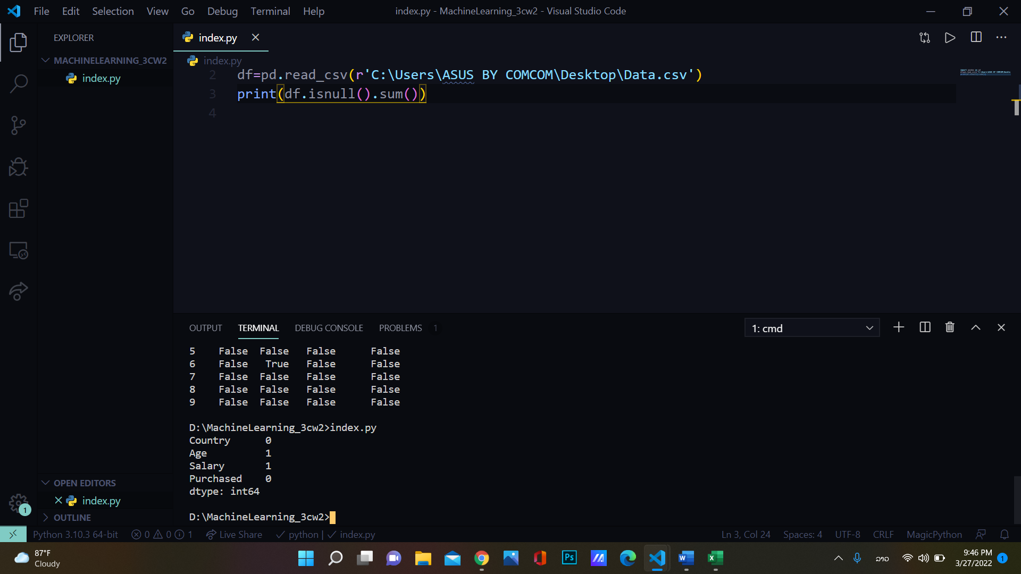

ຜົນອອກ:



#ຄຳສັ່ງ isnull().sum().sum()

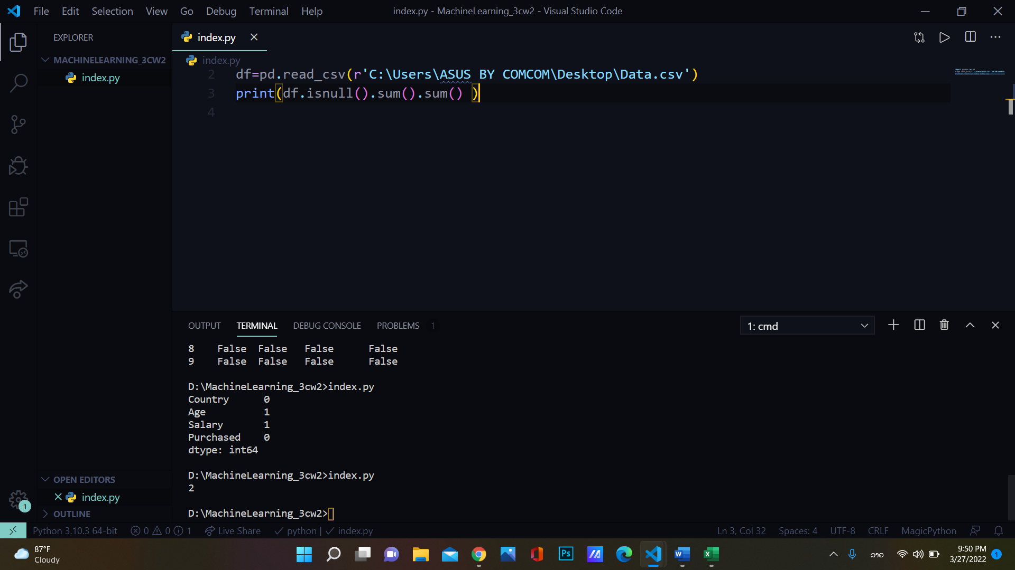

ຜົນອອກ: 2

4. ຈົ່ງແກ້ໄຂບັນຫາຂໍ້ມູນສູນຫາຍດ້ວຍການເຮັດ Preprocessing ຊື່ງສາມາດນຳໃຊ້ຫຼັກການຕ່າງໆໃນເວັບໄຊຕົວຢ່າງນີ້:

<https://stackabuse.com/python-how-to-handle-missing-dataframe-values-in-pandas/>

ການເຮັດ Preprocessing

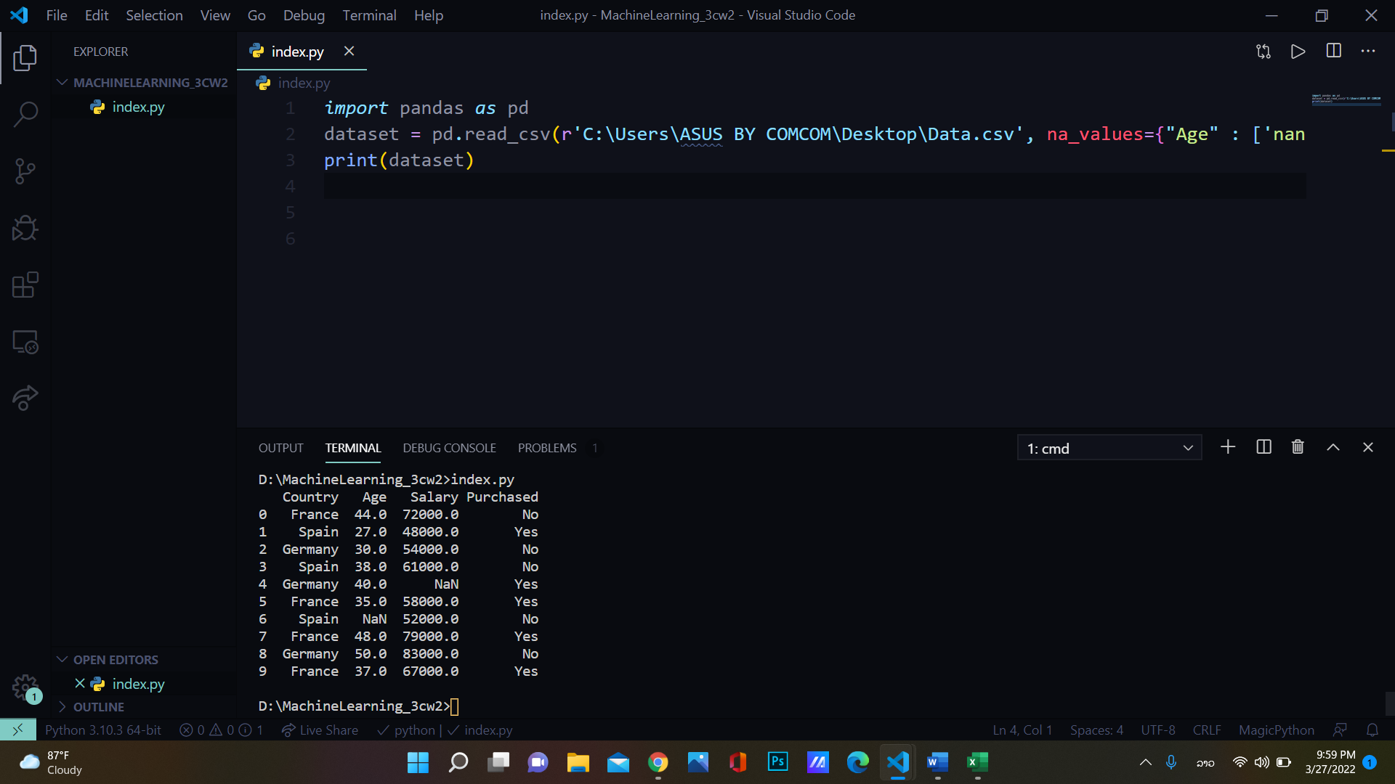

ຜົນອອກ:

